**Experiment 2**

**Aim:** Identify and apply the appropriate CSS tags to format data on webpage

**Theory:**

Introduction of CSS

CSS stands for Cascading Style Sheets. CSS describes how HTML elements are to be displayed on screen, paper, or in other media. CSS saves a lot of work. It can control the layout of multiple web pages all at once. External style sheets are stored in CSS files.

Syntax:

CSS rule consists of a selector and a declaration block. The selector points to the HTML element you want to style. The declaration block contains one or more declarations separated by semicolons. Each declaration includes a CSS property name and a value, separated by a colon.

Multiple CSS declarations are separated with semicolons, and declaration blocks are surrounded by curly braces.

There are three ways of inserting a style sheet:

● External CSS

● Internal CSS

● Inline CSS

**Code:**

body {

font-family: Arial, sans-serif;

}

h1, h2, h3 {

color: #333;

}

header {

background-color: #eee;

padding: 20px;

}

nav ul {

list-style-type: none;

margin: 0;

padding: 0;

}

nav li {

display: inline-block;

margin-right: 20px;

}

main {

max-width: 800px;

margin: 0 auto;

padding: 20px;

}

footer {

background-color: #eee;

text-align: center;

padding: 20px;

}

a {

color: #007bff;

text-decoration: none;

}

a:hover {

text-decoration: underline;

}

article {

margin-bottom: 40px;

}

aside {

border: 1px solid #ddd;

padding: 20px;

}

**Output:**

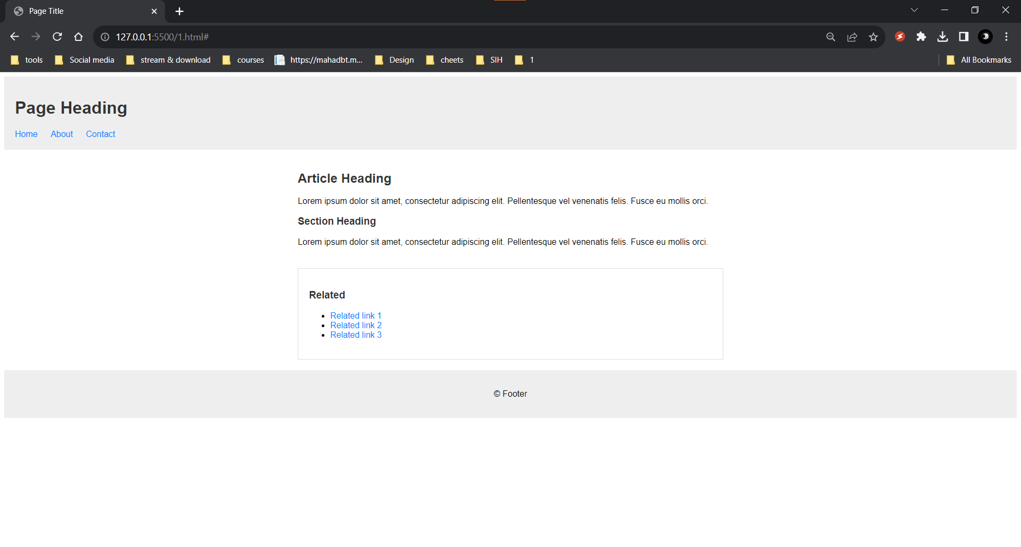

**Conclusion:**